Module #1:

1. Is the ability to model subtype/supertype relationships likely to be important in a hospital environment such as RVH? Justify your answer. (4 marks)
Yes, subtype/supertype relationships are very important in a hospital environment like RVH. They help avoid repeated data by letting shared attributes (such as name, address, birth date, and phone number) stored in a single supertype like Person, while subtypes such as Employee, Physician, Patient, and Volunteer add only the extra attributes they need. This keeps the model clean and prevents duplication.
These relationships also enforce strict data rules. Each subtype introduces its own constraints — for example, nurses have certificates, technicians have skills, and patients split into resident or outpatient, each with different behaviors (like visits for outpatients or bed assignments for residents). Modeling these as subtypes ensures the system validates data correctly and follows the hospital’s actual business logic.
Subtype/supertype structures also make the overall design easier to understand. The hospital has a complex mix of roles and responsibilities and organizing them into a clear hierarchy helps maintain order when dealing with hundreds of staff, patients, and volunteers.
There are downsides: subtype hierarchies can introduce extra joins, which may affect performance, and enforcing some business rules (like minimum cardinality or RN‑only nurse‑in‑charge) can require triggers or additional logic. They also fit relational systems better than NoSQL ones. But overall, for RVH’s environment, subtype/supertype modeling is not just helpful — it’s necessary to accurately represent how the hospital operates.

2. Can the business rules paradigm, and the ability to easily define, implement, and maintain business rules, be used as a competitive advantage in a hospital environment such as RVH? Justify your answer. (4 marks)
Yes, the business‑rules paradigm can absolutely be a competitive advantage in a hospital environment like RVH. I’ve worked with business rules for decades, and the core idea is simple: clearly define the rules the organization must follow and enforce them directly in the system. For a hospital with hundreds of employees and thousands of treatments, strict rule enforcement is essential. If the model allows weak or inconsistent rules, the result is a ripple effect of low‑quality or inaccurate data, which can compromise operations and even patient safety.
Cleaning or reconciling bad data after the fact is slow, expensive, and risky. Old records may lack context and correcting them can break historical reporting or audit trails. By giving RVH the ability to define, implement, and maintain business rules directly in the system, the hospital ensures that data is valid from the moment it is entered. This reduces the need for large data‑cleanup efforts, lowers IT maintenance costs, and ultimately becomes a competitive advantage because the hospital can trust its information and operate more efficiently.
Strict business rules also help enforce hospital policies. For example, ensuring that nurse‑in‑charge roles require an RN certificate, guaranteeing that laboratories always have qualified technicians assigned, or making sure treatments and the items used are properly tracked and auditable. These rules protect the hospital from operational errors and compliance issues. In a complex environment like RVH, the ability to reliably enforce these rules is not just helpful — it’s a strategic advantage.

3. Do there appear to be any weak entities in the description of the data requirements in this project module? Justify your answer. (4 marks)
A week entity is an entity that depends on another for its identification, it doesn’t have primary key of its own. Instead it uses partial key combined with another primary key.
There are several examples of wek entities of this project. They include: Visit (since it cannot exist with out an Outpatient and a date); TreatmentRecord (relies on patient, physician, treatment date, and time) Finally, there is ItemConsumption, which needs patient and item as owners.

4. Draw an EER diagram to accurately represent this set of requirements. State any assumption you had to make in developing the diagram. (14 marks)

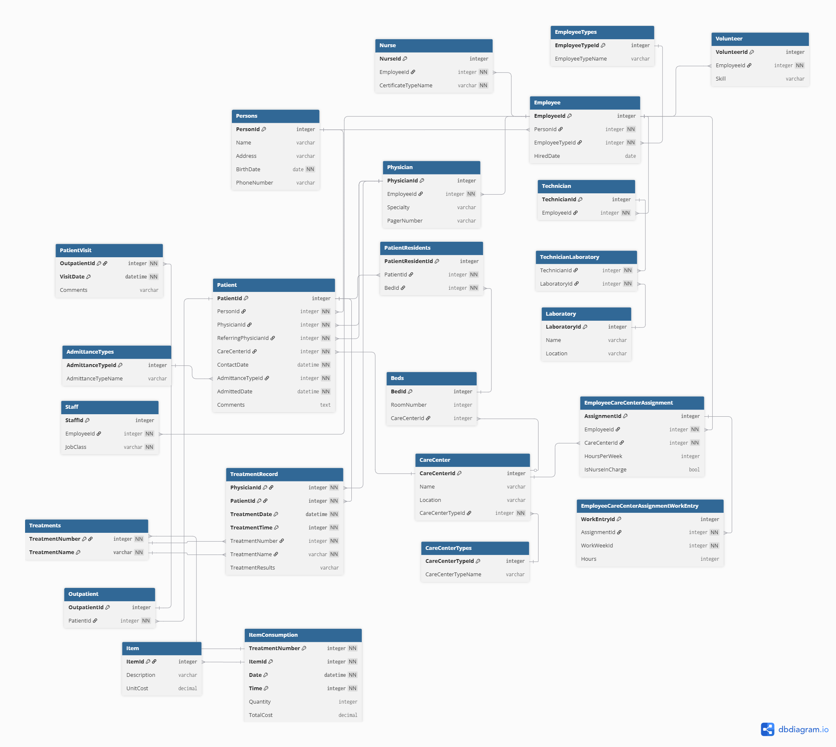
(See ‘EER Diagram.png’)

5. Is there any opportunity for using entity clustering in the RVH EER diagram? Justify your answer. (4 marks)
Yes, there are several exmples of entity clustering in the RVH EER diagram. Entity clustering is where several entities are grouped together with a larger abstract concept. We can see this demonstrated with the following blocks:
Patient cluster:
- Patient, Resident, Outpatient, Visit, PatientResidents are all similarly clustered together as they all relate to patient information
Employee cluster:
- Employee, staff and HR information can all be clustered within the employee cluster. This includes: Emplyee, Nurse, Staff, Technician, Physician and Volunteer
Treatment cluster:
- Treatment information an also be clustered; Treatments, TreatmentRecord, Items and ItemConsumption

